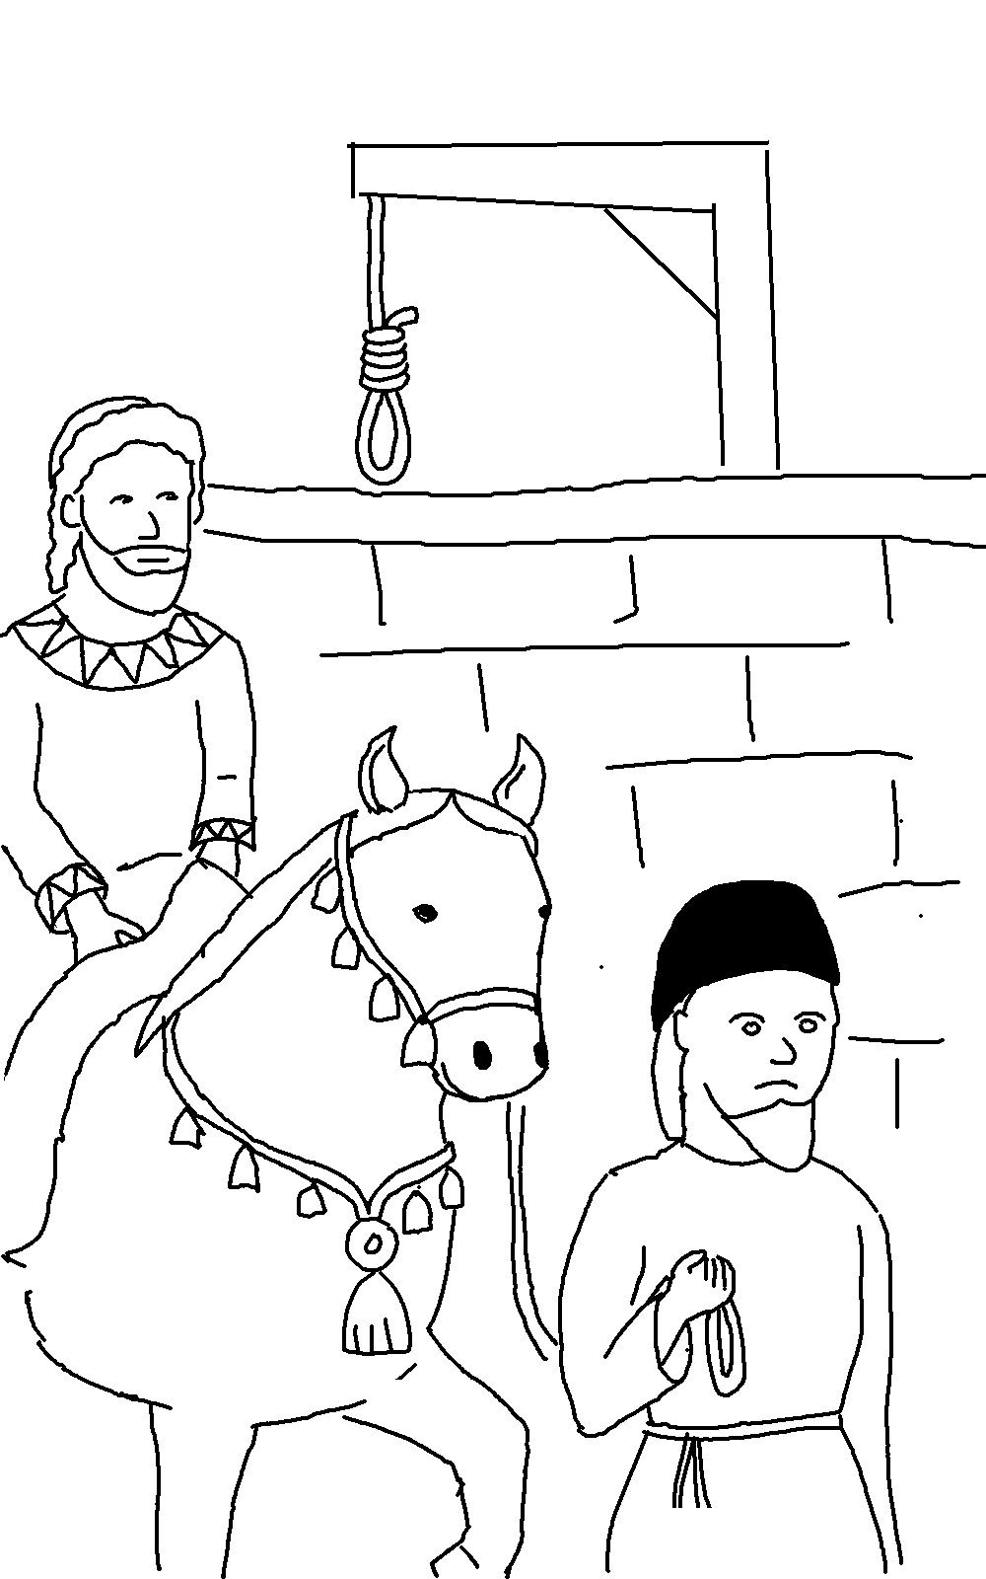
If God is for us, who can ever be against us?
Romans 8:31_{NLT}

